Let’s test out the uploading of a student report.

1. Login with proper credentials

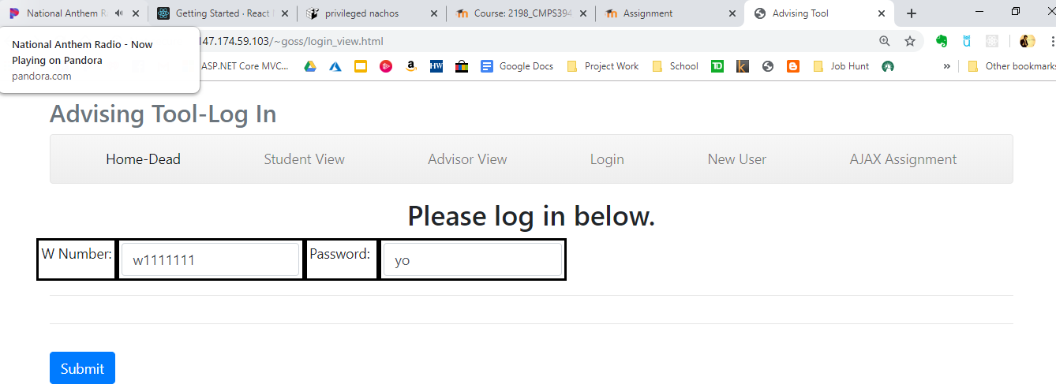

Invalid credentials are challenged with a redirect.

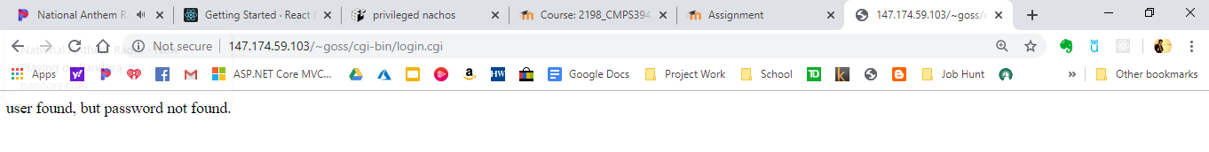

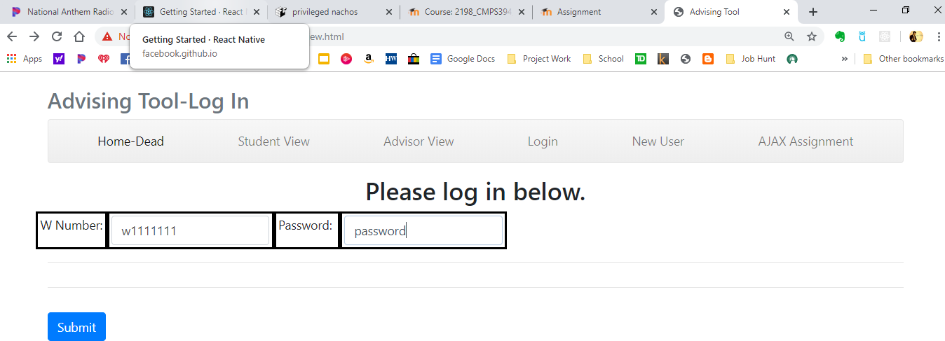

Now logged in.

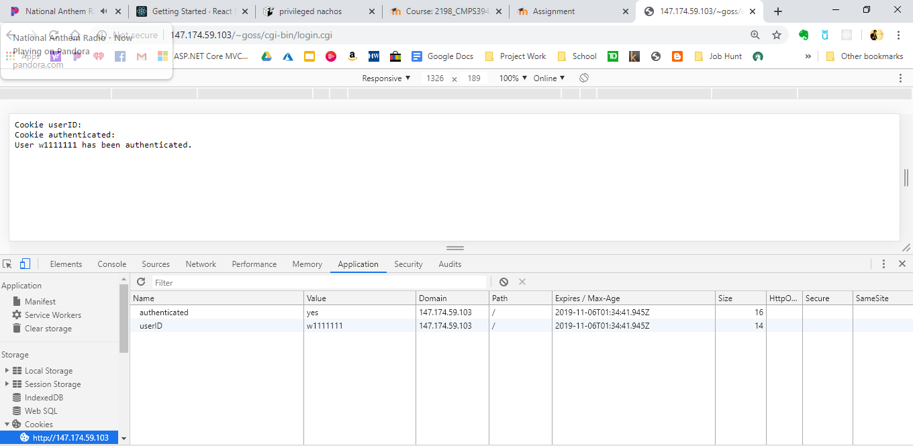

1. Go to the student page and select a file to upload and upload it.

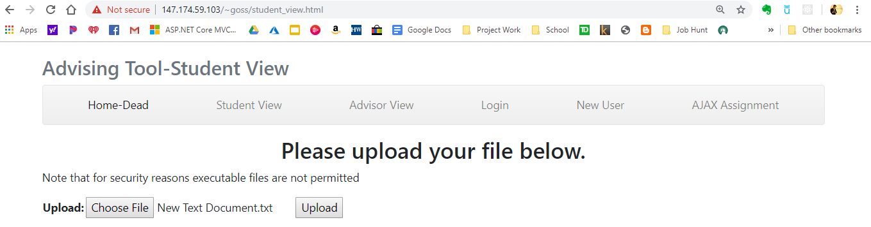

A page is presented that provides information about the upload.

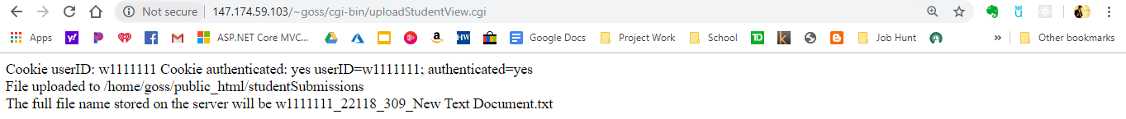

The file can be found on the server here:

